QUESTION#1:
#include <iostream>
using namespace std;
struct Node {
int data;
Node* left;
Node* right;
};
Node* newNode(int val) {
Node* temp = new Node();
temp->data = val;
temp->left = temp->right = NULL;
return temp;
}
void inorder(Node* root) {
if (root == NULL)
return;
inorder(root->left);
cout << root->data << " ";
inorder(root->right);
}
void findDeepest(Node* root, Node*& deepest) {
if (root == NULL)
return;
deepest = root;
findDeepest(root->left, deepest);
findDeepest(root->right, deepest);
}
Node* deleteDeepest(Node* root, Node* deepest) {
if (root == NULL)
return NULL;

if (root == deepest) {
delete root;
return NULL;
}

root->left = deleteDeepest(root->left, deepest);
root->right = deleteDeepest(root->right, deepest);

return root;
}
void deleteNode(Node* root, int key) {
if (root == NULL)
return;

Node* target = NULL;
Node* deepest = NULL;
if (root->data == key)
target = root;

findDeepest(root, deepest);

if (target != NULL && deepest != NULL) {
target->data = deepest->data;
deleteDeepest(root, deepest);
}
}

int main() {
Node* root = newNode(1);
root->left = newNode(2);
root->right = newNode(3);
root->left->left = newNode(4);
root->left->right = newNode(5);

cout << "Before deletion: ";
inorder(root);

deleteNode(root, 2);

cout << "\nAfter deletion: ";
inorder(root);

return 0;
}
OUTPU: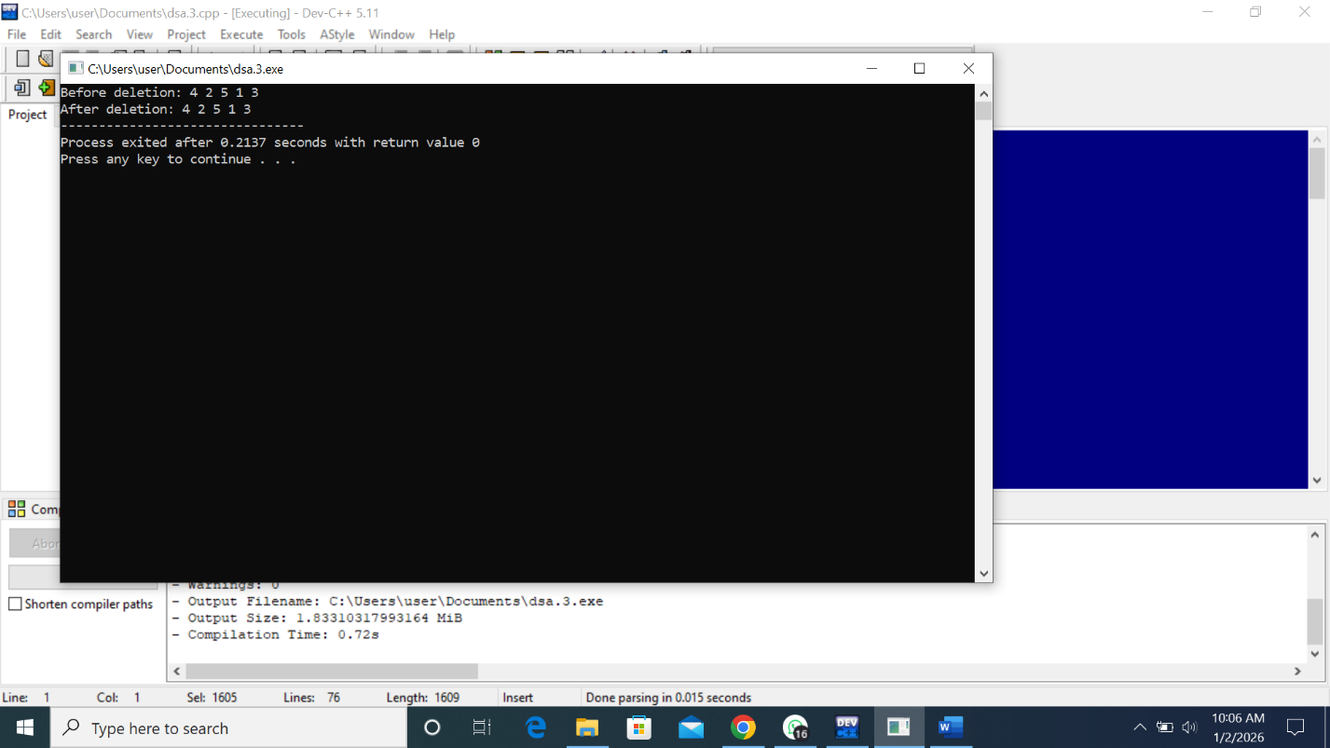
DRY RUN:
1
/ \
2 3
/ \
4 5
INORDER: LEFT->ROOT->RIGHT
Left of 1 → node 2
Left of 2 → node 4 → print 4(PAUSE)
Back to 2 → print 2
Right of 2 → node 5 → print 5(PAUSE)
Back to 1 → print 1
Right of 1 → node 3 → print 3
4 2 5 1 3
NOW delete with 2
Target node with data is 2
Call for function find deepest i)check for 1 deepest is 1
ii) check for 2 iii)check 4 iv) check 5 v) check 3 is the deepest
target node will be replaced with deepest
1
/ \
3 3
/ \
4 5
Delete deepest node
1
/ \
3 NULL
/ \
4 5 after deletion
Left of 1 → node 3
Left of 3 → node 4 → print 4
Back to 3 → print 3
Right of 3 → node 5 → print 5
Back to 1 → print 1
After deletion 4 3 5 1

QUESTION # 2:
#include <iostream>
using namespace std;
struct Node {
int data;
Node* left;
Node* right;
};
Node* newNode(int val) {
Node* temp = new Node();
temp->data = val;
temp->left = temp->right = NULL;
return temp;
}
Node* insert(Node* root, int val) {
if (root == NULL)
return newNode(val);

if (val < root->data)
root->left = insert(root->left, val);
else
root->right = insert(root->right, val);

return root;
}

Node* minValueNode(Node* node) {
while (node->left != NULL)
node = node->left;
return node;
}
Node* deleteNode(Node* root, int key) {
if (root == NULL)
return root;

if (key < root->data)
root->left = deleteNode(root->left, key);
else if (key > root->data)
root->right = deleteNode(root->right, key);
else {
// case1&2
if (root->left == NULL) {
Node* temp = root->right;
delete root;
return temp;
}
else if (root->right == NULL) {
Node* temp = root->left;
delete root;
return temp;
}

//case3
Node* temp = minValueNode(root->right);
root->data = temp->data;
root->right = deleteNode(root->right, temp->data);
}
return root;
}
void removeDuplicates(Node* root) {
if (root == NULL)
return;

removeDuplicates(root->left);
removeDuplicates(root->right);

if (root->right && root->right->data == root->data) {
root->right = deleteNode(root->right, root->data);
}
}
void inorder(Node* root) {
if (root == NULL)
return;
inorder(root->left);
cout << root->data << " ";
inorder(root->right);
}

int main() {
Node* root = NULL;
int values[] = {5, 3, 7, 3, 8, 5};
for (int i = 0; i < 6; i++)
root = insert(root, values[i]);

cout << "Inorder before removing duplicates: ";
inorder(root);

removeDuplicates(root);

cout << "\nInorder after removing duplicates: ";
inorder(root);

return 0;
}
DRY RUN:
Values 5, 3, 7, 3,8,5
5
/ \
3 7
\ \
3 8
\
5
Inorder 3 3 5 5 7 8
Remove duplicate postorder
Node 3 right child 3duplicate found
delete right 3

5
/ \
3 7
/\
8
/
5 tree after duplicate deletion

Output: